

**Course Name:** Introduction to Database

**Course Teacher:** JUENA AHMED NOSHIN

**Section:D**

**Project Name: FOOD DELIVERY MANAGEMENT SYSTEM**

Group Members:

|  |  |
| --- | --- |
| NAME | ID |
| Khan, Md. Nasir | 17-34469-2 |
| MD.NURUZZAMAN RASHID | 17-35087-2 |
| NAIMUR RAHMAN | 17-34549-2 |
| MD. MUHAIMANUR RASHID | 17-34480-2 |

**Content List:**

|  |  |
| --- | --- |
| **No.1** | **Introduction** |
| **No.2** | **Scenario** |
| **No.3** | **ER Diagram** |
| **No.4** | **Normalization** |
| **No.5** | **Table creation** |
| **No.6** | **Data Insertion** |
| **No.7** | **Query Writing** |
| **No.8** | **Conclusion** |

**Introduction:** A Database Management System (DBMS) is a computer software application that interacts with end-users and other application and the database itself to capture and analyze data. A general- purpose DBMS allows the definition, creation, querying, update and administration of database.

In our project (Food delivery management system) the concept of DBMS used. So, this project mainly focuses of realizing the basic concepts of Database Management System, (DBMS).

**SCENARIO:** In a food delivery management system, a customer can place many orders .A customer is identified by a customer id, also customer name, email and multiple phone number is store in the system. A customer has a Address. An address is identified by an address id, also place and zip code is store in the system. An order identified by an order no, also class, time, date, status is stored. A restaurant can take many orders. A restaurant is recognize by restaurant id, also restaurant name, phone number and multiple email is stored. A order has many foods. Foods are identified by food id, also food name, description, price and quantity stored in the system. An order also have payment. A payment is identified by payment id, also payment type and net price is stored. A restaurant hide many employee. Employees are identified by employee id, also employee name, salary and multiple phone number are stored in the system. Employee use vehicles to delivers orders. A vehicle is identified by vehicle id, also registration no and type is store in the system. A vehicle deliver many parcel or delivery. Delivery is identified by product id, also arrival, arrival time, place, signature is stored in the system.

**Normalization**

**Food-*-order details-*-orders**

UNF:

Order details(food_id,food_name,price,description,qty,order_no,time,class,date,status)

1NF

There is no multivalued attribute.

(food_id,food_name,price,description,qty,order_no,class,date,status)

2NF

1.(food_id, food_name,price,description,qty)

2.(order_no,time,class,date,status)

3NF

1.(food_id ,price,qty )

2.(food_name,description)

3.(order_no,class,status)

4.(time,date)

Table Creation:

1.(food_id,price,qty,**f_id**)

2. (f_id , food_name ,description)

3.(order_no,class,status,**D_id**)

4.(D_id,time,date)

5.(**food_id**,**order_no**)

**Orders-*-places-1-customer**

**UNF**

Places (order_no, time, class, date, status, customer id, phone, name, email)

1NF

Phone is a multivalued attribute.

(Order no, time, class, date, status, customer id, phone, name, email)

**2NF**

1. (Order no, time, class, date, status)

2. (Customer id, phone, name, email)

**3NF**

1. (Order no, class, status)

2. (Time, date)

3. (Customer id, phone, name, email)

Table creation

1. (Order no, class, status, **D_id, customer_id**)

2. (D_id, Time, date)

3. (Customer id, phone, name, email)

**Orders-*-take-1-resturants**

UNF

Take (order no, time, class, status, date, R_id, r_name, r_phone, email)

1NF

r_Phone is a multivalued attribute

(Order no, time, class, status, date, R_id, r_name, r_phone, email)

2NF

(Order no, time, class, status, date)

(R_id, r_name, r_phone, email)

3NF

(Order no, class, status)

(Time, date)

(R_id, r_name, r_phone, email)

Table creation

1. (order no, class, status, **D_id**, **R_id**)

2. (D_id, time, date)

3. (R_id, r_name, r_phone, email)

***Orders-1-have-1-payment***

UNF

Have(order_no,time,class,date,status,payment_id,payment_type,netprice)

1NF

There is no multivalued attribute.

(order_no,time,class,date,status,payment_id,payment_type,netprice)

2NF

1.(order_no,time,class,date,status)

2.(payment_id,payment_type,netprice)

3NF

1.(order_no,class,status)

2.(time,date)

3.(payment_id,payment_type,netprice)

Table Creation:

1.(order_no,class,status,**D_id,payment_id**)

2.(D_id,time,date)

3.(payment_id,payment_type,netprice)

**Resturants-1-hire-*-employee**

**UNF**

Hire (R_id, r_name, r_phone, email, employee id, employee_name , phone, salary)

1NF

Phone are multivalued attributes.

(R id, r_name, r_phone, email, employee id, employee_name, phone, salary)

2NF

1., (R_id,r_name, r_phone, email)

2. ( employee id, employee_name, phone, salary)

3NF

1. (R id, r_name, r_phone, email)

2. ( employee id, employee_name, phone, salary)

Table creation

1. (R_id, r_name, r_phone, email)

2. ( employee id, employee_name, phone, salary, **r_id**)

**Customer-*-lives at-1-address**

UNF

Lives at(Customer Id, phone, name, email, Address id, place, zip code, signature)

1NF

Phone is a multivalued attribute.

(Customer id, phone, name, email. Address id, place , zip code , signature)

2NF

1. (Customer id, phone, name, email)

2. (Address id, place, zip code, signature)

3NF

1. (Customer id, phone, name, email.)

2. (Address id, place, zip code, signature)

Table creation

1. (Customer id, phone, name, email, **Address_id**)

2. (Address id, place, zip code, signature)

**Employee-1-delivers by-1-vehicles**

UNF

Delivers by(employee_id, employee_name, phone, salary, vehicles id, registration_no, type )

1NF

Phone is a multivalued attribute.

(employee_id, employee_name, phone, salary, vehicles id, registration_no, type )

2NF

1. (employee_id, employee_name, phone, salary )
2. (vehicles id, registration_no,type )

3NF

1. (employee_id, employee_name, phone, salary )
2. (vehicles id, registration_no,type )

Table creation

1. (employee_id, employee_name, salary,phone, **vehicles_id** )
2. (vehicles id, registration_no,type )

**Vehicles-1-delivers-*-delivery**

UNF

Delivers(vehicles id, registration_no, type, product_id, arrival, arrival_time,signature )

1NF

There is no multivalued attribute

(vehicles id, registration_no, type, place, signature, product_id, arrived, arrival_time )

2NF

1. (vehicles id, registration_no, type)
2. (product id, place, signature, arrived, arrival_time )

3NF

1. (vehicles id, registration_no, type)
2. (product id, place)
3. (arrived, arrival_time, signature)

Table creation

1.(vehicles_id, registration_no, type)

3.(product_id, arrival, arrival_time, signature,**vehicles_id**)

Table creation:

1.orders(order_no,class,status,**D_id**,**customer_id,R_id,payment_id**)

2.customer(customer_id,phone,name,email,**address_id**)

3.Addresses(Address_id,place,zip_code,signature)

4.Timendate(D_id,Tm,dt)

5.resturent(R_id,r_name,r_phone,email)

6.employee(employee_id,employee_name,phone,salary,**R_id,vehicles_id**)

7.vehicles(vehicles_id,registration_no,type)

8.deliver(product_id,arrival,arrival_time,signature,**vehicles_id**)

9.food(food_id,price,qty,**f_id**,)

10.description(f_id,food_name,description)

11.payment(payment_id,payment_type,netprice)

**Query writing:**

1. CREATE TABLE ORDERS(ORDER_NO NUMBER(10) PRIMARY KEY,CLASS VARCHAR2(20),STATUS VARCHAR2(20),D_ID NUMBER(10),CUSTOMER_ID NUMBER(10),R_ID NUMBER(10),PAYMENT_ID NUMBER(10));

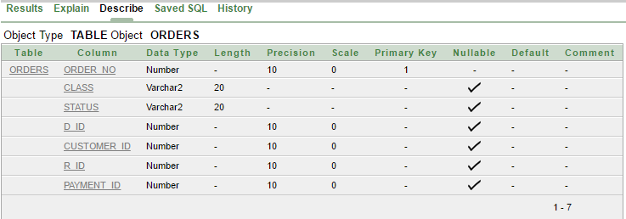

2. CREATE TABLE CUSTOMERS(CUSTOMER_ID NUMBER(10) UNIQUE,PHONE NUMBER(11),C_NAME VARCHAR2(20),EMAIL VARCHAR2(30),ADDRESS_ID NUMBER(10),CONSTRAINT CUSTOMER_ID PRIMARY KEY(CUSTOMER_ID,PHONE));

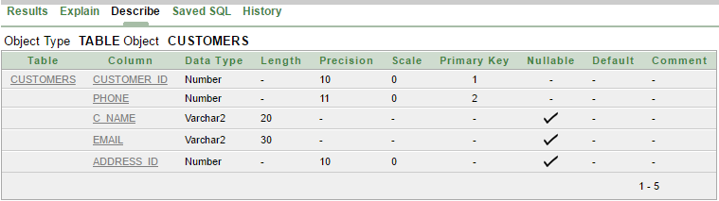

3. CREATE TABLE ADDRESS(ADDRESS_ID NUMBER(10) PRIMARY KEY,PLACE VARCHAR2(20),ZIP_CODE NUMBER(10),SIGNATURE VARCHAR2(20));

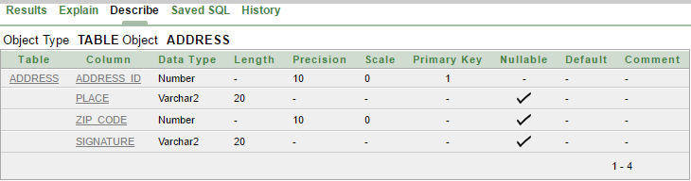

4.CREATE TABLE TIMENDATE(D_ID NUMBER(10)PRIMARY KEY,DT NUMBER(20),TM NUMBER(10));

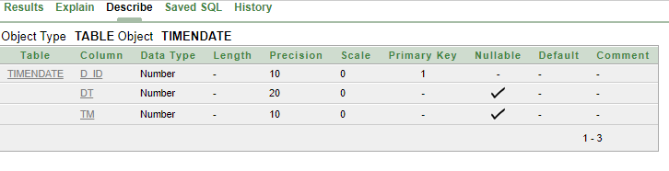

5. CREATE TABLE RESTURANT(R_ID NUMBER(10) UNIQUE,R_NAME VARCHAR2(20),R_PHONE NUMBER(11),EMAIL VARCHAR2(20),CONSTRAINT RESTURANT_ID PRIMARY KEY(R_ID,R_PHONE));

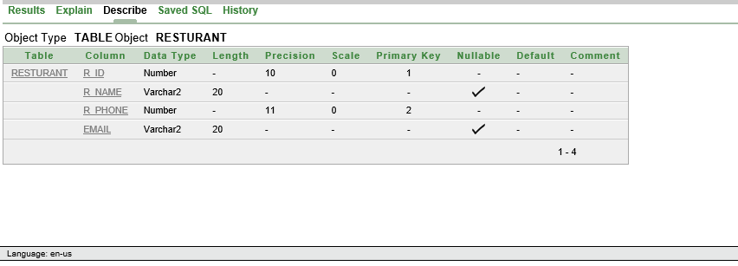

6. CREATE TABLE EMPLOYEE(EMPLOYEE_ID NUMBER(10) UNIQUE,EMPLOYEE_NAME VARCHAR2(20),PHONE NUMBER(11),SALARY NUMBER(10),R_ID NUMBER(10),VEHICLES_ID NUMBER(10), CONSTRAINT EMPLOYEE_ID PRIMARY KEY(EMPLOYEE_ID,PHONE));

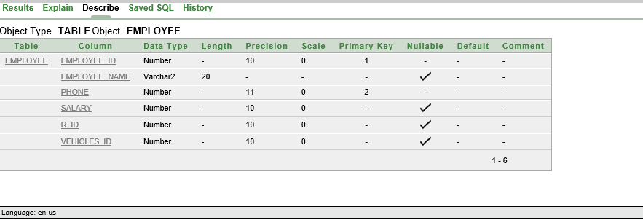

7. CREATE TABLE VECHICLES(VECHICLES_ID NUMBER(10)PRIMARY KEY,REGISTRATION_NO NUMBER(10),TYPE VARCHAR2(10));

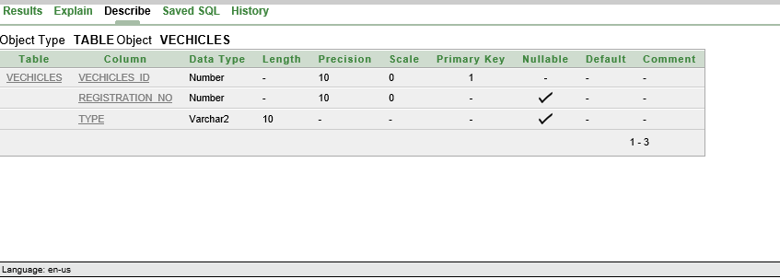

8. CREATE TABLE DELIVER(PRODUCT_ID NUMBER(10) PRIMARY KEY,ARRIVAL_DATE VARCHAR2(20),ARRIVAL_TIME NUMBER(5),SIGNATURE VARCHAR2(20),VEHICLES_ID NUMBER(10));

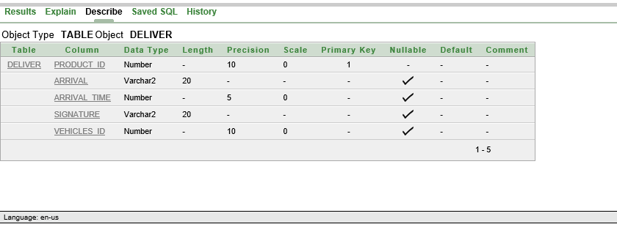

9.CREATE TABLE FOOD(FOOD_ID NUMBER(10)PRIMARY KEY,PRICE NUMBER(10),QTY NUMBER(5),F_ID NUMBER(10));

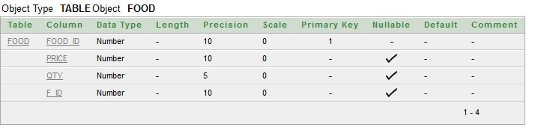

10.CREATE TABLE DESCRIPTION(F_ID NUMBER(10)PRIMARY KEY,FOOD_NAME VARCHAR2(20),DESCRIPTION VARCHAR2(20));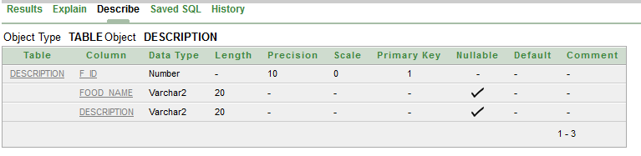

11. CREATE TABLE PAYMENT(PAYMENT_ID NUMBER(10)PRIMARY KEY,PAYMENT_TYPE VARCHAR2(10),NETPRICE NUMBER(10))

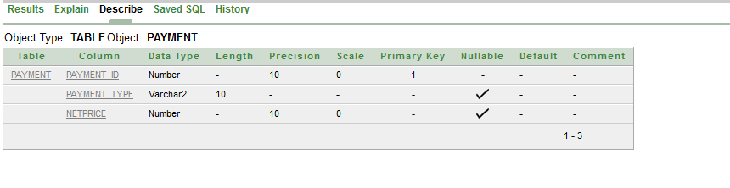

Constraints:

1.Alter table orders add constraint fk foreign key(D_id) references Timendate(D_id);

2.Alter table orders add constraint fk1 foreign key(customer_id) references customer(customer_id);

3.Alter table orders add constraint fk2 foreign key(payment_id) references payment(payment_id);

4.Alter table customer add constraint fk3 foreign key(address_id) references Address(address_id);

5.Alter table employee add constraint fk4 foreign key(R_id) references resturent(R_id);

6.Alter table employee add constraint fk5 foreign key(vehicles_id) references vehicles (vehicles_id);

7.Alter table deliver add constraint fk6 foreign key(vehicles_id) references vehicles(vehicles_id);

8.Alter table food add constraint fk7 foreign key(f_id) references description(f_id);

**DATA INSERTION:**

**1.orders:**

insert into orders(order_no,class,status,D_id,customer_id,R_id,payment_id) values('1','middle','none','1001','101','101','23456');

insert into orders(order_no,class,status,D_id,customer_id,R_id,payment_id) values('2','delicious','expensibble dinner','1002','102','102','23458');

insert into orders(order_no,class,status,D_id,customer_id,R_id,payment_id) values('3','fast food','breakfast','1003','103','103','23460');

insert into orders(order_no,class,status,D_id,customer_id,R_id,payment_id) values('4','low','drinking','1004','104','104','23466');

insert into orders(order_no,class,status,D_id,customer_id,R_id,payment_id) values('5','high','chinese','1005','105','105','23476');

**2.customers:**

insert into customers(CUSTOMER_ID,PHONE,C_NAME,EMAIL,ADDRESS_ID) values('101','012345789','RIAZ','RIAZUDDIN88@GMAIL.COM','7902');

insert into customers (CUSTOMER_ID,PHONE,C_NAME,EMAIL,ADDRESS_ID) values('102','012345788','MIRAJ','MIRAJ77@GMAIL.COM','7901');

insert into customers (CUSTOMER_ID,PHONE,C_NAME,EMAIL,ADDRESS_ID) values('103','012345689','RAFI','IKRAMRAFI66@GMAIL.COM','7903');

insert into customers (CUSTOMER_ID,PHONE,C_NAME,EMAIL,ADDRESS_ID) values('104','012344789','KAMRUL','STRKAMRUL55@GMAIL.COM','7904');

insert into customers (CUSTOMER_ID,PHONE,C_NAME,EMAIL,ADDRESS_ID) values('105','012335789','SHANTO','KAMRUJSHANTO44@GMAIL.COM','7905');

**3.Addresses:**

insert into addresses (ADDRESS_ID,PLACE,ZIP_CODE,SIGNATURE) values('7902','COMILLA','34576','RZ');

insert into addresses (ADDRESS_ID,PLACE,ZIP_CODE,SIGNATURE) values('7901','FENI','34577','MJ');

insert into addresses (ADDRESS_ID,PLACE,ZIP_CODE,SIGNATURE) values('7903','NOAKHALI','34578','RI');

insert into addresses (ADDRESS_ID,PLACE,ZIP_CODE,SIGNATURE) values('7904','CHITAGONG','34579','STR');

insert into addresses (ADDRESS_ID,PLACE,ZIP_CODE,SIGNATURE) values('7905','CHANDPUR','34588','SHT');

**4.Timendate:**

insert into timendate(D_ID,tm,dt) values('1001','15:30','13-01-2018');

insert into timendate(D_ID,tm,dt) values('1002','17:30','12-01-2018');

insert into timendate(D_ID,tm,dt) values('1003','13:44','10-01-2018');

insert into timendate(D_ID,tm,dt) values('1004','16:23','14-01-2018');

insert into timendate(D_ID,tm,dt) values('1005','13:20','15-01-2018');

**5.Resturants:**

insert into resturant(r_id,r_name,r_phone,email) values('101','pranto','01793456765','pranto96@gmail.com');

insert into resturant(r_id,r_name,r_phone,email) values('102','rahim','01793456766','rahim96@gmail.com');

insert into resturant(r_id,r_name,r_phone,email) values('103','riad','01793456763','riad96@gmail.com');

insert into resturant(r_id,r_name,r_phone,email) values('104','tanvir','01793456754','tanvir96@gmail.com');

insert into resturant(r_id,r_name,r_phone,email) values('105','nafi','01793456755','nafi96@gmail.com');

**6.Employee:**

insert into employee(employee_id,employee_name,phone,salary,r_id,vehicles_id) values('401','karim','01792502188','9765','101','201');

insert into employee(employee_id,employee_name,phone,salary,r_id,vehicles_id) values('402','sagor','01792502178','9777','102','202');

insert into employee(employee_id,employee_name,phone,salary,r_id,vehicles_id) values('403','tuhin','01792502168','9665','103','203');

insert into employee(employee_id,employee_name,phone,salary,r_id,vehicles_id) values('404','akanto','01792502158','9865','104','204');

insert into employee(employee_id,employee_name,phone,salary,r_id,vehicles_id) values('405','borkat','01792502138','9762','105','205');

**7.Vehicles:**

insert into vehicles(vehicles_id,registration_no,type) values('201','4533','toyota');

insert into vehicles(vehicles_id,registration_no,type) values('202','4534','bike');

insert into vehicles(vehicles_id,registration_no,type) values('203','4536','cycle');

insert into vehicles(vehicles_id,registration_no,type) values('204','4538','toyota');

insert into vehicles(vehicles_id,registration_no,type) values('205','4540','toyota');

**8.Delivers:**

insert into deliver(product_id,arrival_date,arrival_time,signature,vehicles_id) values('301','2-3-2018','10:30','LO','201');

insert into deliver(product_id,arrival_date,arrival_time,signature,vehicles_id) values('302','4-5-2018','11:30','RO','202');

insert into deliver(product_id,arrival_date,arrival_time,signature,vehicles_id) values('303','2-6-2018','09:30','MO','203');

insert into deliver(product_id,arrival_date,arrival_time,signature,vehicles_id) values('304','1-3-2018','08:30','KO','204');

insert into deliver(product_id,arrival_date,arrival_time,signature,vehicles_id) values('305','3-4-2018','12:30','AO','205');

**9.Food:**

INSERT INTO FOOD (FOOD_ID ,PRICE ,QTY,F_ID) VALUES ('2345','200','2','123');

INSERT INTO FOOD (FOOD_ID ,PRICE ,QTY,F_ID) VALUES ('2350','250','5','121');

INSERT INTO FOOD (FOOD_ID ,PRICE ,QTY,F_ID) VALUES ('2365','250','3','120');

INSERT INTO FOOD (FOOD_ID , PRICE ,QTY,F_ID) VALUES ('2330','260','2','122');

INSERT INTO FOOD (FOOD_ID , PRICE ,QTY,F_ID) VALUES ('2335','170','4','124');

**10.Description:**

INSERT INTO DESCRIPTION (F_ID ,FOOD_NAME ,DESCRIPTION) VALUES ('123','PIZZA','VEGITABLE');

INSERT INTO DESCRIPTION (F_ID ,FOOD_NAME ,DESCRIPTION) VALUES ('120','AMERICAN BURGER','AMERICAN');

INSERT INTO DESCRIPTION (F_ID ,FOOD_NAME ,DESCRIPTION) VALUES ('122','CHICKEN BURGER','CHECKEN');

INSERT INTO DESCRIPTION (F_ID ,FOOD_NAME ,DESCRIPTION) VALUES ('121','PASTA','ITALIAN');

INSERT INTO DESCRIPTION (F_ID ,FOOD_NAME ,DESCRIPTION) VALUES ('124','AZZURII','ITALIAN');

**11.Payment:**

INSERT INTO PAYMENT(PAYMENT_ID ,PAYMENT_TYPE,NETPRICE) VALUES ('23456','VISA','600');

INSERT INTO PAYMENT(PAYMENT_ID ,PAYMENT_TYPE,NETPRICE) VALUES ('23458','UPAY','1000');

INSERT INTO PAYMENT(PAYMENT_ID ,PAYMENT_TYPE,NETPRICE) VALUES ('23460','BIKASH','450');

INSERT INTO PAYMENT(PAYMENT_ID ,PAYMENT_TYPE,NETPRICE) VALUES ('23466','VISA','900');

INSERT INTO PAYMENT(PAYMENT_ID ,PAYMENT_TYPE,NETPRICE) VALUES ('23476','CASH','360');

**Query Writing:**

**single-row functions :**

**Que:Display all data of orders 1.**

**Ans:select * from orders where order_id=’1’;**

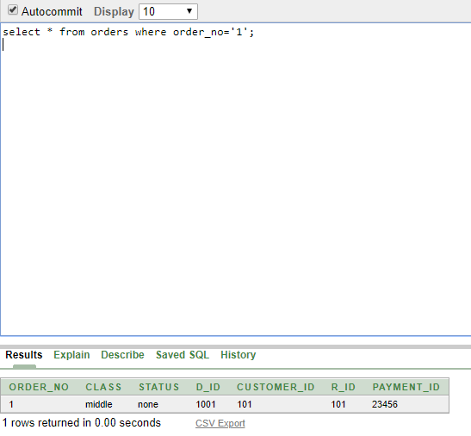

**Que:display all data of customer Riaz.**

**Ans:select * from customer where c_name=’RIAZ’;**

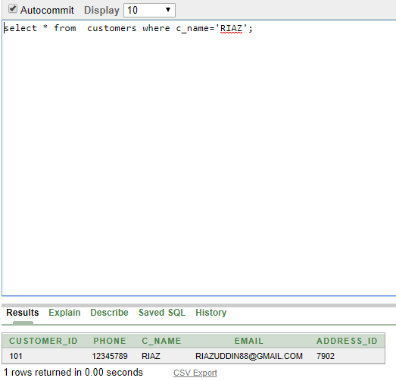

**Que:find all data of Rahim restaurant.**

**Ans:select * from restaurant where r_name=’rahim’;**

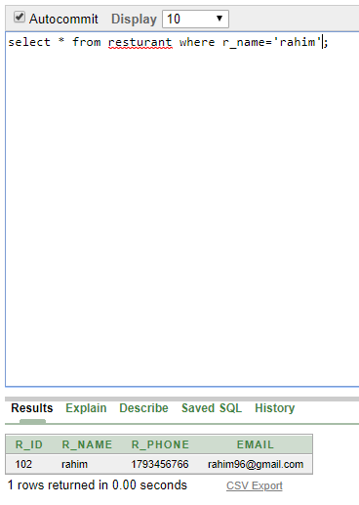

***Group functions:***

**Ques:find average price of all food.**

**Ans:select avg(price) from food;**

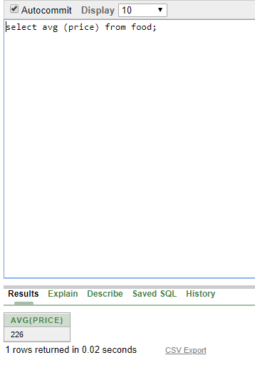

**Que:find total quantity of food.**

**Ans:select sum(qty) from food;**

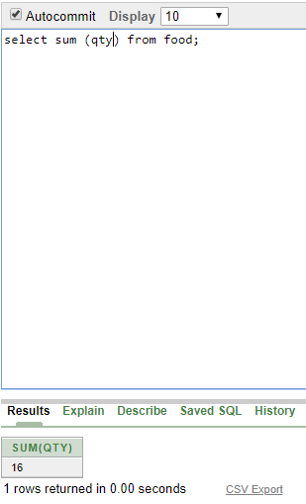

**Que:find address of Miraz.**

**Ans:select address_id from customers where c_name=’MIRAZ’;**

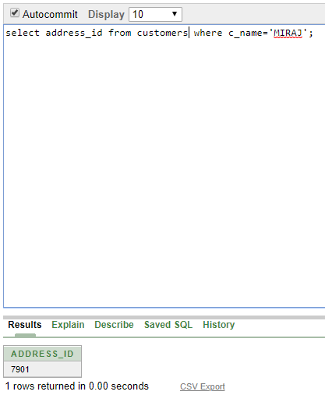

***subquery* :**

**1.** **Select employee_name from employee where salary>(select salary from employee**

**where employee_name='borkat');**

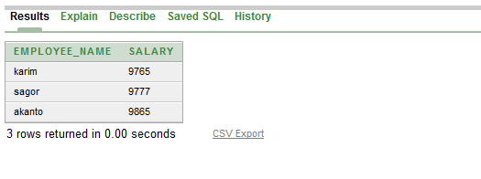

2. Select payment_type from payment where NETPRICE>(select NETPRICE from payment

where payment_id='23460');

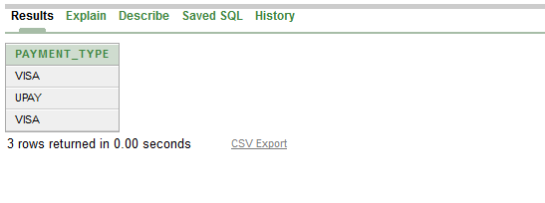

***joining*:**

1. Select employee.employee_name ,vehicles.type from employee, vehicles where employee.vehicles_id=vehicles.vehicles_id and type='toyota';

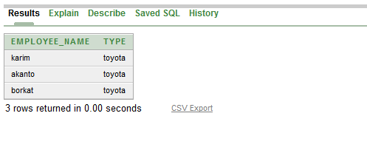

**Conclusion:**

**After finishing the project we have learned many things about creating a database, Creating scenarios, Normalisation, Table making, Query Writing, Data insertion and much more. It is an interesting Project.**